**Lab Exercise # 10**

**Name:** Josiah Joed G. Getes

**Course & Year:** BSCS – 1

**Objectives:** To create a base class for a circle shape with the appropriate member variables and functions.

To derive another class from the base class for a related shape, then override some function from it.

To implement the function of the base class and the derived class

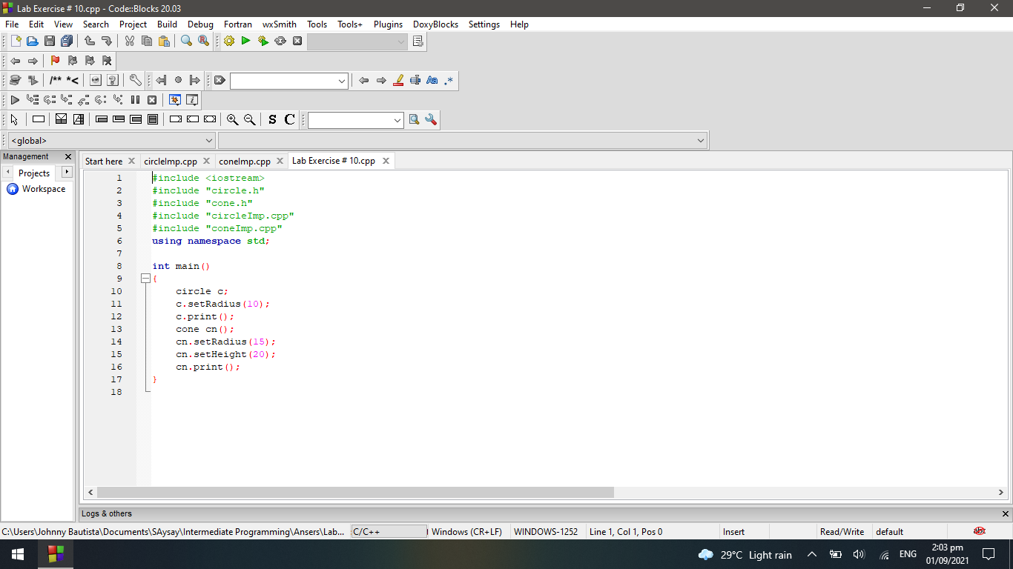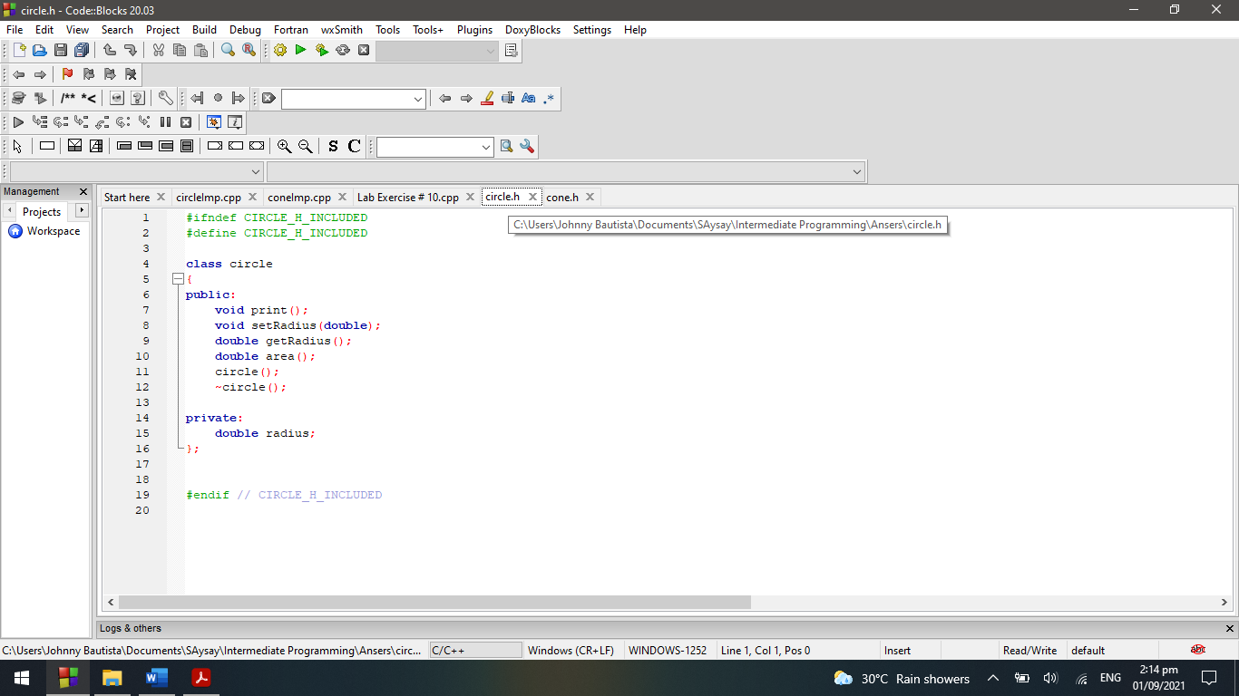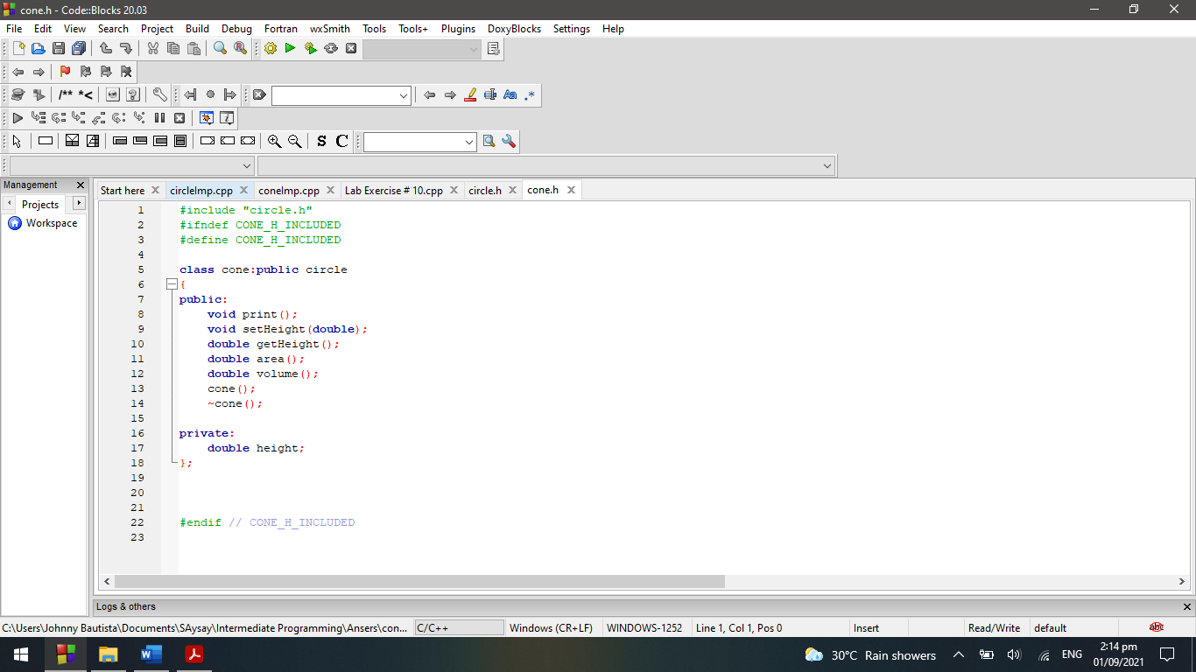**CODE: HEADER FILES:**

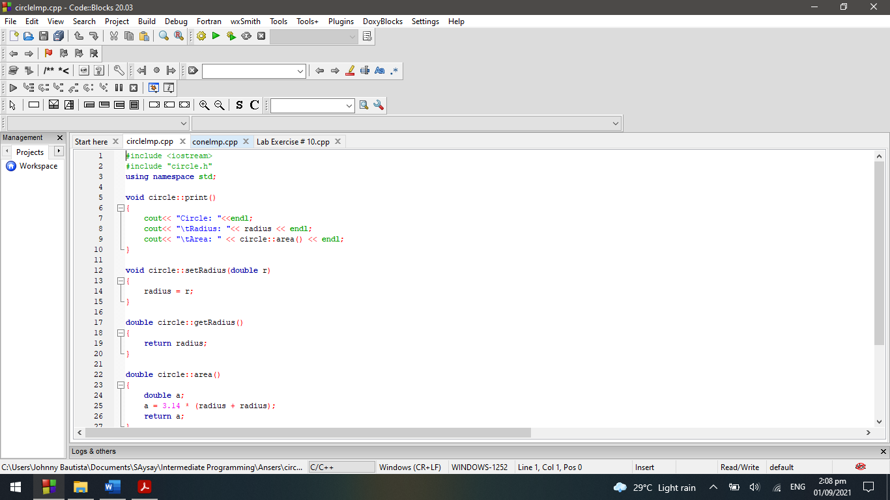

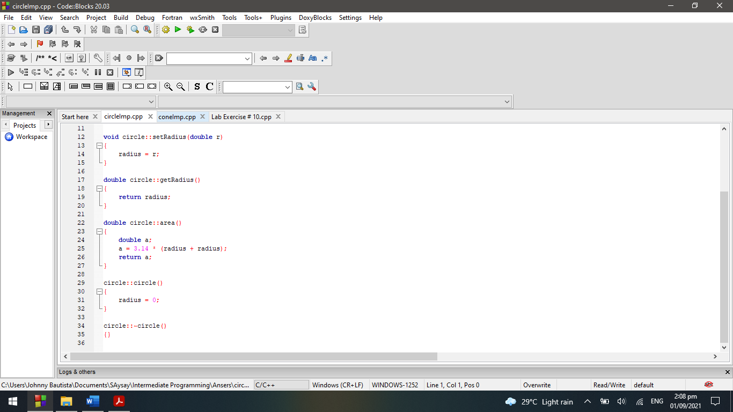

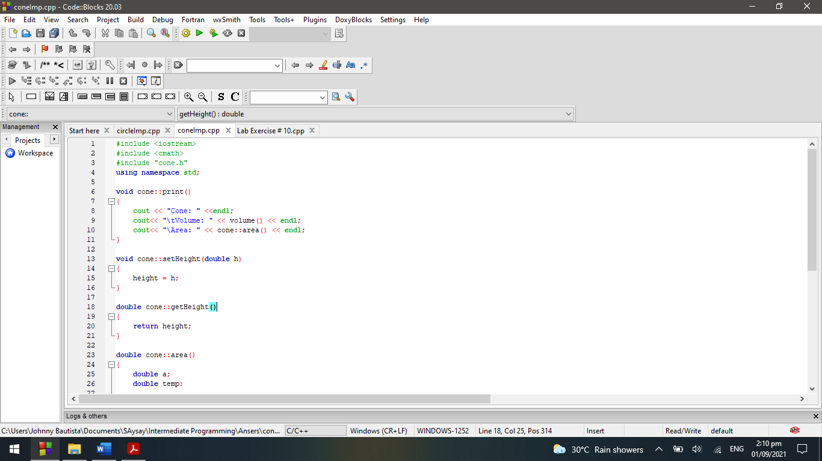

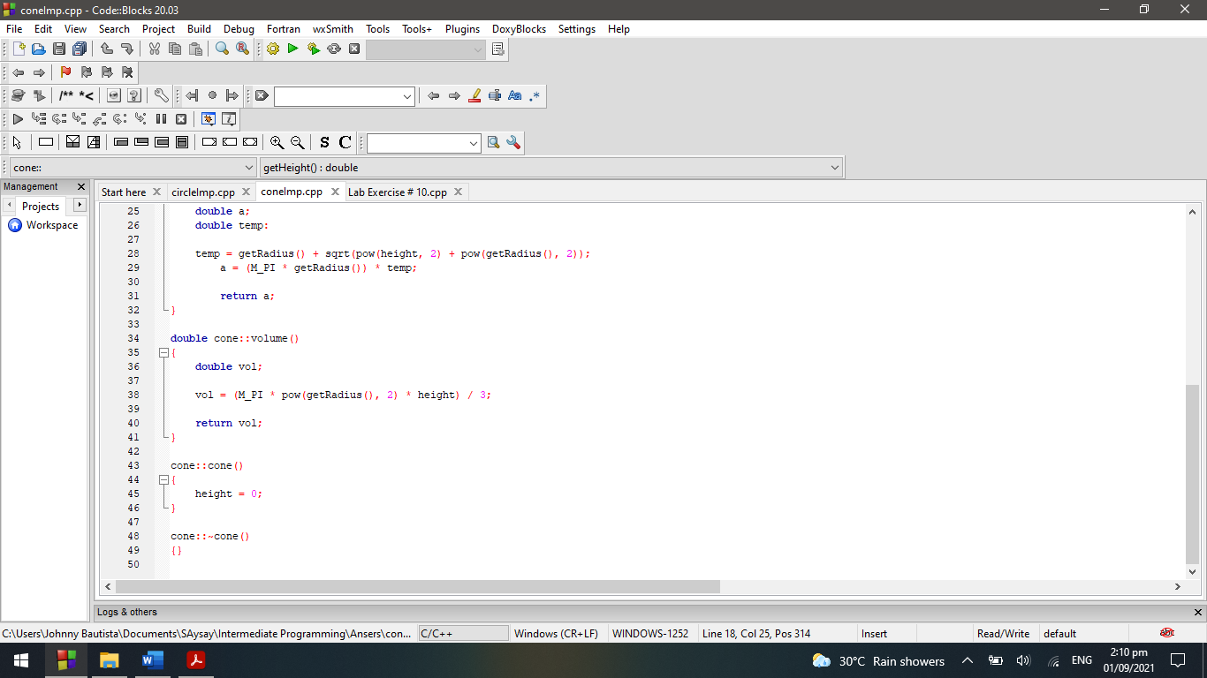

**OUTPUT:**

